**Structures and Algorithms Coursework Testing and Analysis**

**Step1**

For step 1, I implemented almost every feature required. My step 1 displays the main menu and present the users with options that all work, that stores the inputs they take which can then display and the ability to search for them. The data structure I have takes in the values and stores them in order from when they are brought in, the data structure can also remove the members based on the keywords provided by the user to remove it. It presents the inputs in order from when they are taken in. Using the dynamic structure, any input can be added or removed.

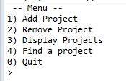





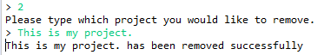

When projects is empty



When projects has contents



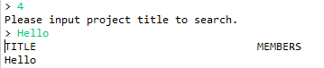



**Step2**

Step2 is very similar to step1 but resolving around building up the team member structure to proceed forward. The dynamic data structure also applies to this step and makes sure that data can be entered and withdrew from within the program if necessary.

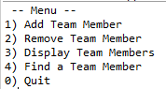

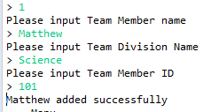



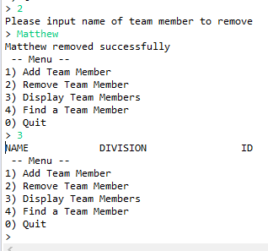



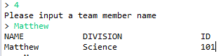

**Step3**

For Step3, I couldn’t fully get everything working, so I will present it as is. I have it so that the program presents everything and provides with the binary search tree in order to look for everything. I had a lot of issues with this part, in how to get it working in the first place. I hopefully believe that it is in a finessed enough state without adding some of the features. I simplified some of the variable names and objects and classes. I couldn’t get the name to appear when listed under a project in step 3 either, I couldn’t find a way to resolve this in time and was probably the biggest step for me instead of it returning a null value would have been nice, so will lose some marks for that.

